PRT661 – Data Science Practice | Australian Electricity Demand Forecasting | WP4
Bishal Dahal — WP4 Individual Contribution & Progress Report
Dan6 Theme 2 (Group 2) | Final modelling analysis, deep-learning evaluation and production model selection
Table 1. Student and WP4 role
Student | ID | WP4 role | Workstream / pair
Bishal Dahal | S388095 | Independent MLP validation, expanded metrics and evidence | MLP pair with Ashish Shrestha (implementation); primary for neural comparison and regression testing

Evidence note
Numerical statements in this report come from the full academic run of Energy_Demand_Forecasting_Pipeline.py v4.0.0 (EnergyForecast_Run_20260929_145931, 426.7 minutes, status COMPLETE). Methodology statements refer to the same pipeline version.
The WP4 module attributed to Bishal is a current role-aligned collaboration artefact prepared from the team's integrated implementation for genuine branch-based review and merging. It does not claim or back-date earlier authorship. At the date of this report the module has been prepared and verified against the pipeline; the GitHub issue, branch, pull request and review described below are the next collaboration step and have not yet been created. Earlier-stage contributions follow the role boundaries recorded in the WP3 documents and the Meeting 6 minutes.

1. Allocated WP4 responsibility
Bishal's WP4 responsibility is independent validation of the MLP. In WP3 he owned the feature-safety gate, the naive baselines, the metric definitions and the verification figures; in WP4 that role extends to checking a model he did not build, using only the files the integrated pipeline wrote. The validation covers training behaviour, accuracy metrics (MAE, RMSE, sMAPE, nMAE, Bias, MASE, R²), residuals, peaks, year-to-year stability, lead-time behaviour and the comparison with the strongest previous model. He is also primary for the cross-model neural comparison and the final regression/equivalence tests.

2. Validation approach
The validation is deliberately read-only: it never retrains a model, so it cannot alter the experiment. It has three layers. First, it re-derives published metrics from the 1.9-million-row interval-level forecast file using the pipeline's own metric function, which tests whether the summary tables faithfully describe the raw forecasts. Second, it classifies every learning curve with rules declared in advance. Third, it rebuilds the MLP evidence tables from the outputs and writes a plain-English summary generated from those tables, so no number is typed by hand.
Table 2. Declared learning-curve classification rules
Verdict rule | Definition
CONVERGED | Early stopping ended the fit near its validation minimum
OVERFITTING_SIGNAL | Final validation loss > 1.10 × best validation loss while training loss kept falling
EPOCH_LIMIT_REACHED | Best epoch = last epoch = configured limit (possible under-training)

3. Validation results on the final run
Table 3. Independent MLP validation (outputs of WP4_Bishal_MLP_Validation_Evidence.py)
Check | Result | Interpretation
Metric re-derivation from all_models_backtest_detail.csv.gz | 24 MLP region-years; maximum absolute difference 0.00005 | Published MLP metrics are reproducible from the raw forecasts
Learning-curve verdicts | 21 CONVERGED, 3 OVERFITTING_SIGNAL, 0 EPOCH_LIMIT_REACHED | No sign of under-training; mild late overfitting in 3 fits
Best epoch | median 9 (range 5–26) of a 100-epoch limit | Early stopping worked as designed
Generalisation gap at best epoch | mean 0.016 (scaled Huber loss) | Small; training loss is not evidence of forecast skill
MLP better than champion (selection origins) | 2 of 18 region-years (NSW1 2024, WA 2023) | Occasional, not systematic
MLP better than champion (2022 warm-up) | 3 of 6 regions | Relatively robust with short history; not selection evidence
Mean MAE change vs champion | +12.6% across regions; 0 material improvements | No region justifies the MLP

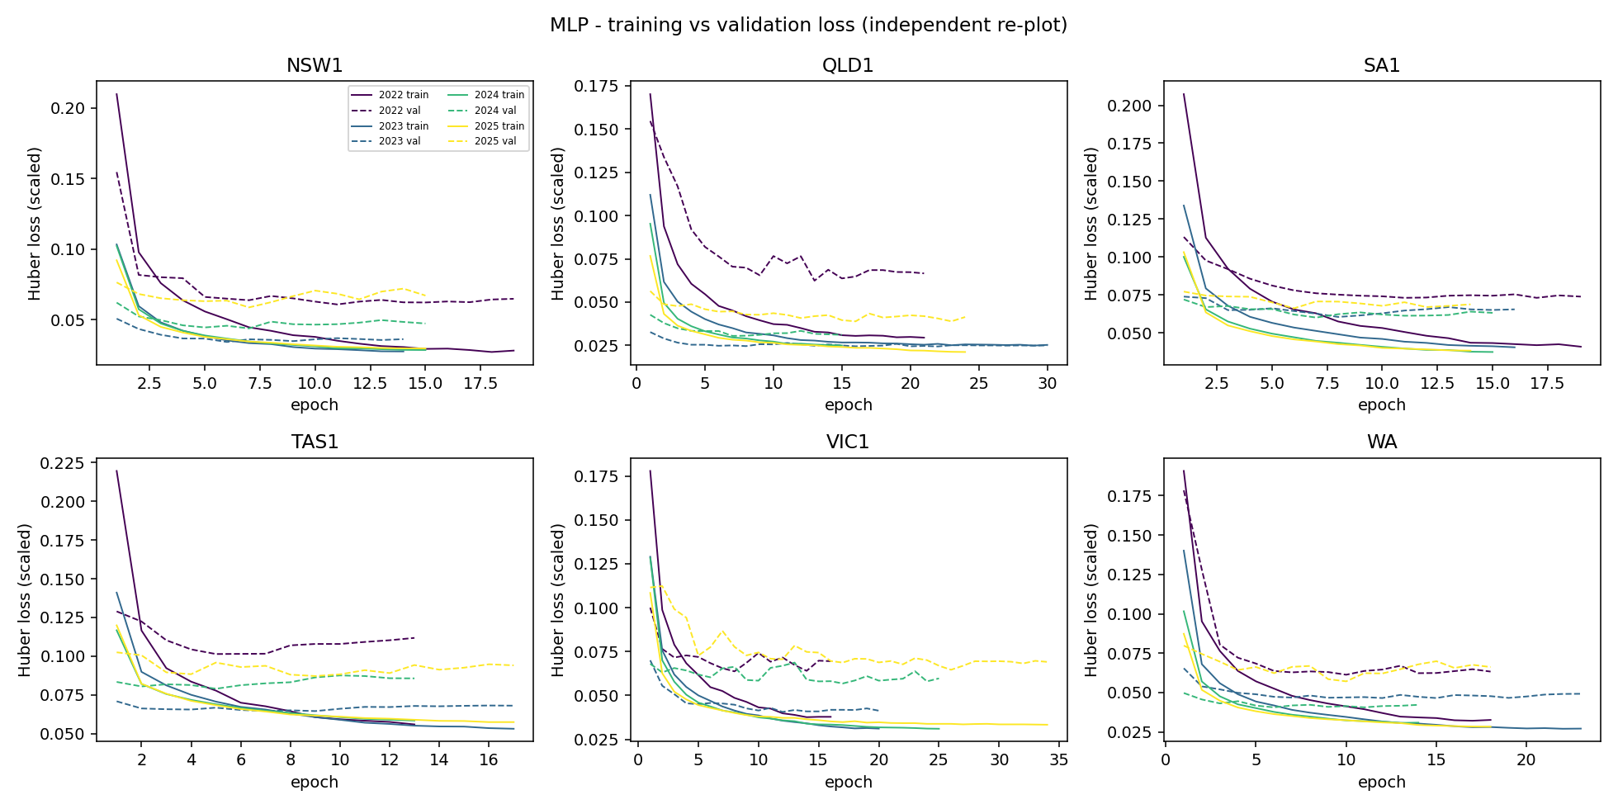
Figure 1. Independent re-plot of MLP training vs validation loss, drawn by the validation module from neural_training_history.csv.
The independent plot matches the pipeline's N01 figure and supports the classification: validation loss flattens within roughly 5–10 epochs, the 2022 curves sit higher (less history), and a few curves (for example VIC1 2025) drift upward after their minimum. Because the MLP is not under-trained, extra epochs would not plausibly close its gap to Random Forest.
Table 4. Expanded MLP evidence compared with the selected models
Evidence area | MLP | Selected Random Forest | Source
Peak-interval MAE (mean over regions) | 657 MW | 541 MW (RandomForest_A) | peak_demand_metrics.csv
Peak bias (mean over regions) | −609 MW | −486 MW (RandomForest_A) | peak_demand_metrics.csv
Change vs champion, Days 1–7 | +5.9% to +53.6% | — | neural_vs_previous_comparison.csv
Change vs champion, Months 2–4 | +1.8% to +23.3% | — | neural_vs_previous_comparison.csv
Origin-to-origin MAE spread (sd) | 7.4 MW (WA) to 71.5 MW (QLD1) | 3.9 MW (WA) to 55.0 MW (QLD1) | model_stability.csv

Precision, recall and F1 appear in the peak outputs but were treated as secondary diagnostics: they answer whether a model flagged a defined high-demand day, not how accurate the forecast was. The primary evidence remains the four-month MAE and its supporting error metrics.

4. WP4 module delivered
Table 5. Module summary
Item | Detail
File | Individual_Code/WP4_Bishal_MLP_Validation_Evidence.py; also maintains run_wp4_equivalence_tests.py
Main functions | load_results(), learning_curve_summary(), plot_learning_curves(), recompute_from_detail(), compare_with_published(), mlp_year_table(), mlp_horizon_table(), mlp_peak_table(), mlp_residual_table(), mlp_stability_table(), export_mlp_evidence()
Contract objects | TrainingHistory, MetricResult (computed only by the pipeline's metrics())
Integration target | Sections J, U–X, Y (N01) and the MLP rows of Section Z exports; reads outputs only
Test result | Self-test PASS; full run on the final outputs PASS (max difference 0.00005); whole suite 6/6 groups pass

5. Collaboration, review and next steps
Table 6. Issues from GitHub_Issues/ (package numbers)
Package issue | Title | Bishal's role | Branch
02 | MLP validation and evidence framework | Owner | wp4/bishal-mlp-validation
03 | MLP pair integration review | Co-owner with Ashish | review only
07 | Cross-model neural vs previous comparison | Primary (Ashish reviews) | follow-up on own branch
10 | Final regression tests and output-equivalence check | Primary (all four review) | wp4/neural-model-integration
01, 11 | MLP integration; report evidence | Reviewer | —

- Extend the year and horizon tables to GRU and GRU_L672 and reconcile them with neural_vs_previous_comparison.csv (Issue 07).
- Review Ashish's MLP PR by running its equivalence checks locally.
- Run the full equivalence suite after each integration merge and record the output in the PR (Issue 10).
- Spot-check report numbers against the evidence register (Issue 11 review).

6. Professional reflection
Bishal's WP4 contribution is the check that makes the other results trustworthy. Re-deriving every published MLP metric from the raw interval forecasts turned "the table says so" into "the forecasts show so". Writing the learning-curve rules before interpreting the curves prevented the common mistake of reading whatever pattern one hopes to see into a plot. The key lesson is the separation of builder and validator: the person who implements a model should not be the only person who decides whether it works. (Reflection to be confirmed and personalised by the student before submission.)

